Test Case: tc001_SPX_Dev5_Crear_Requisicion_Spot_Tipo_Cobro_CC
Step 1 - Enter username and password and click to button Enter : Credentials Entered
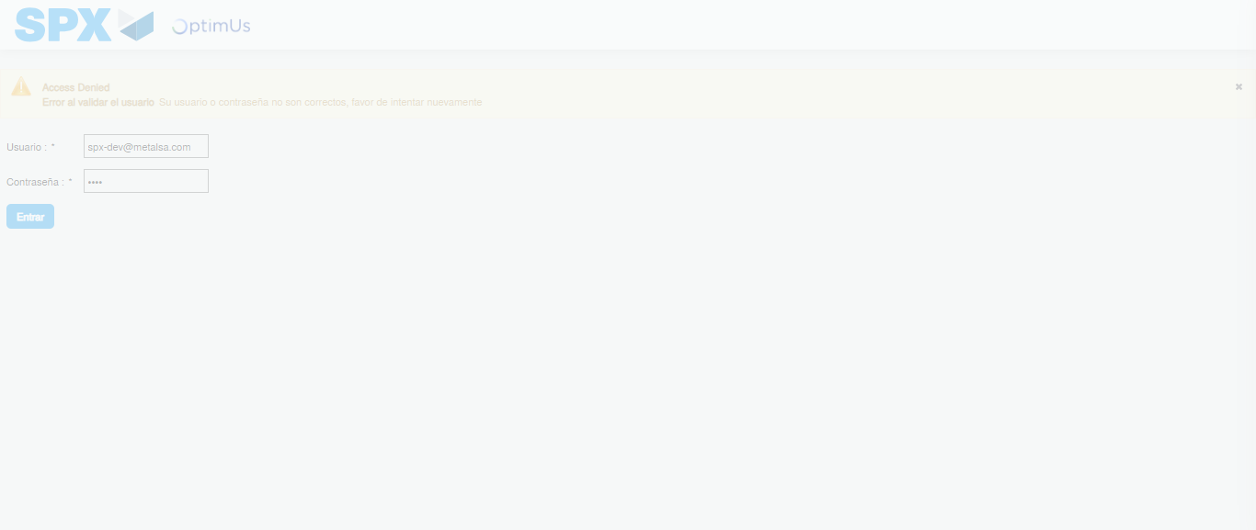Image file-name: QC_Testing-tc001_SPX_Dev5_Crear_Requisicion_Spot_Tipo_Cobro_CC-1782164521697

Step 2 - Select to UEN and Access to Spot Buy Requisitions : UEN Correctly selected and Correct access
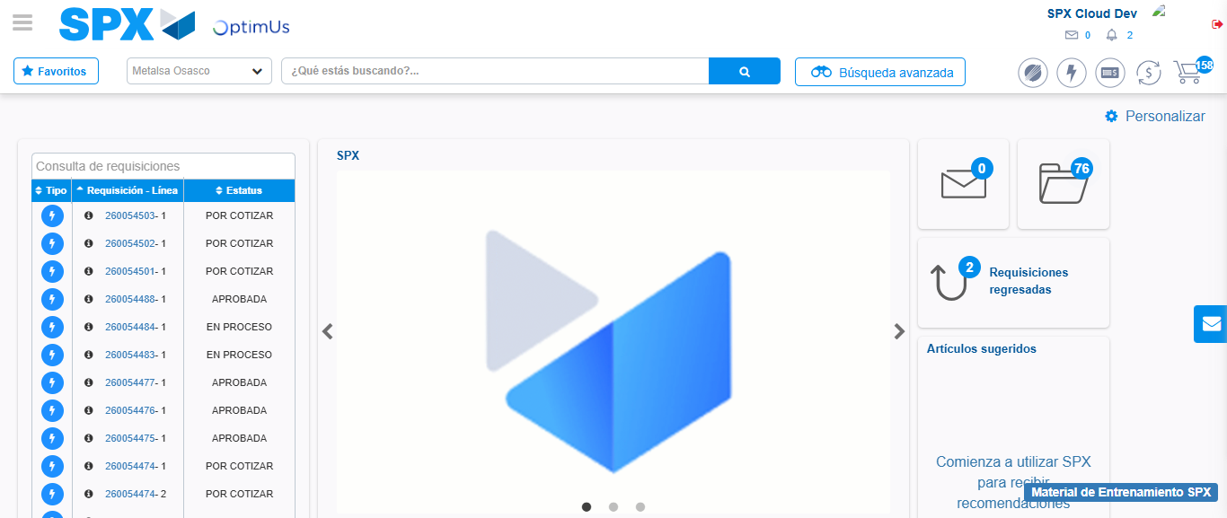Image file-name: QC_Testing-tc001_SPX_Dev5_Crear_Requisicion_Spot_Tipo_Cobro_CC-1782164610884

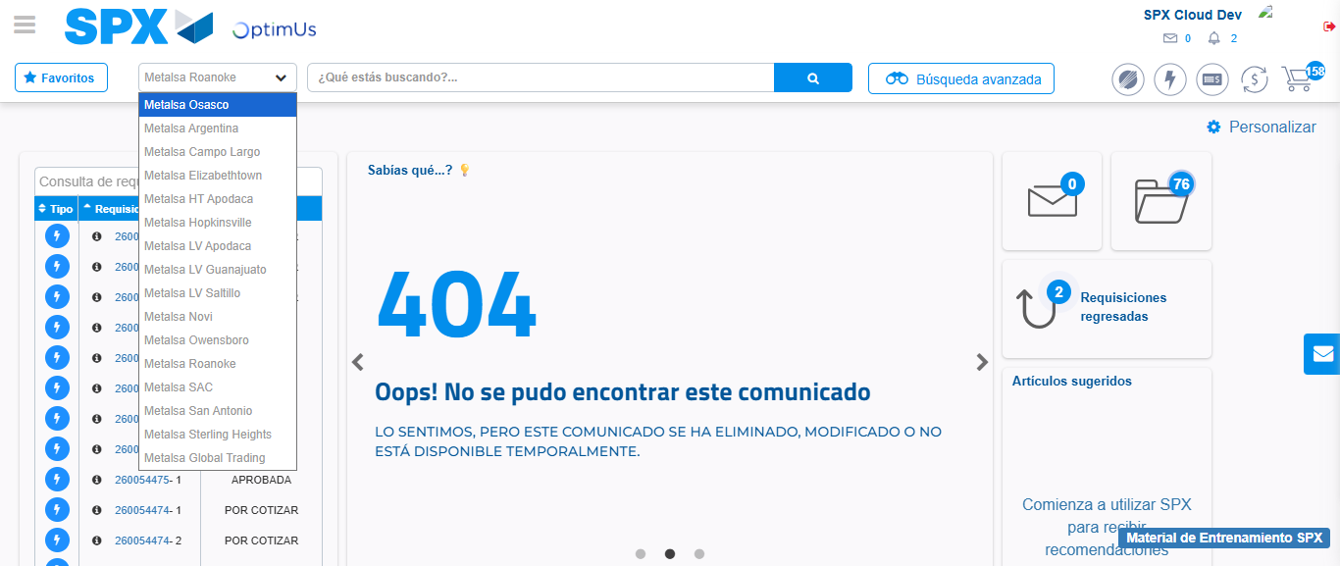Image file-name: QC_Testing-tc001_SPX_Dev5_Crear_Requisicion_Spot_Tipo_Cobro_CC-1782164613448

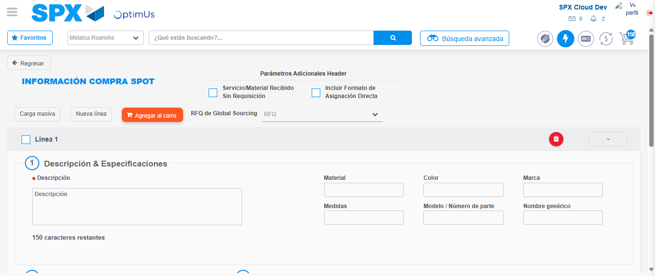Image file-name: QC_Testing-tc001_SPX_Dev5_Crear_Requisicion_Spot_Tipo_Cobro_CC-1782164619554

Step 3 - Data Capture Spot Buy Requisition : Data captured correctly
Image file-name: QC_Testing-tc001_SPX_Dev5_Crear_Requisicion_Spot_Tipo_Cobro_CC-1782164619775

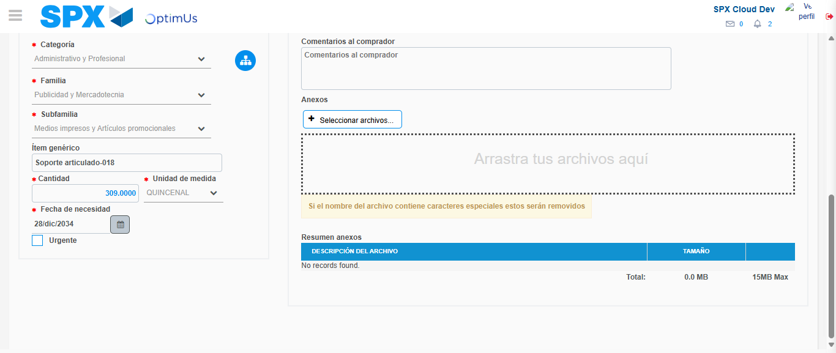Image file-name: QC_Testing-tc001_SPX_Dev5_Crear_Requisicion_Spot_Tipo_Cobro_CC-1782164631199

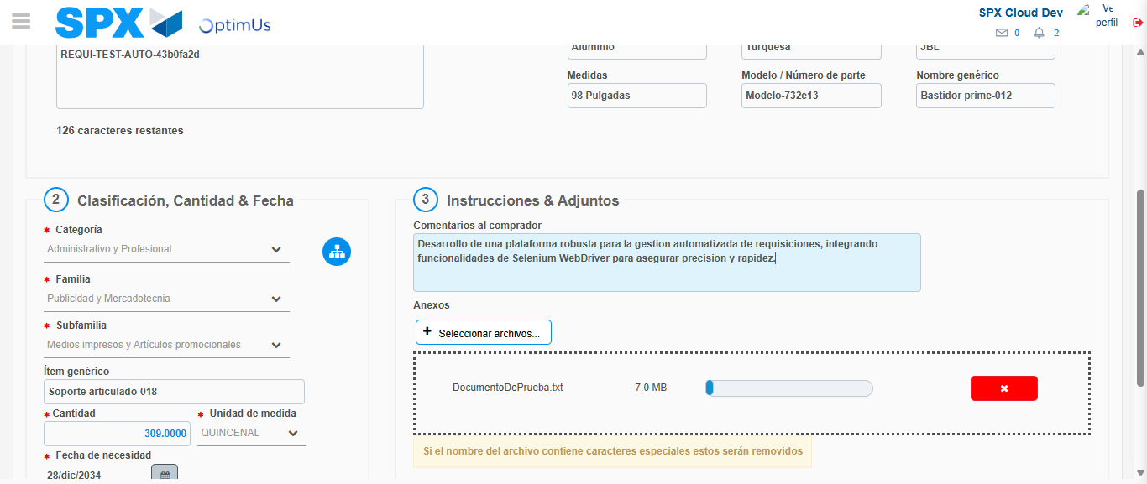Image file-name: QC_Testing-tc001_SPX_Dev5_Crear_Requisicion_Spot_Tipo_Cobro_CC-1782164631982

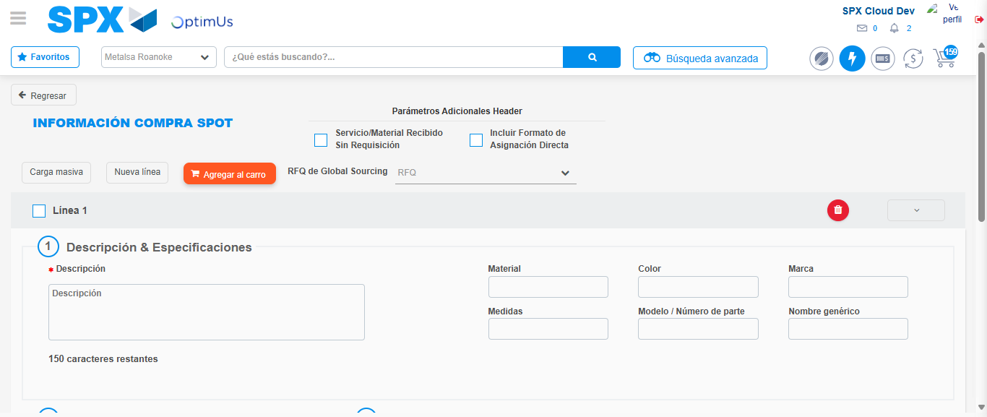Image file-name: QC_Testing-tc001_SPX_Dev5_Crear_Requisicion_Spot_Tipo_Cobro_CC-1782164635469

Step 4 - Select to Requisition : Requisition Correctly selected
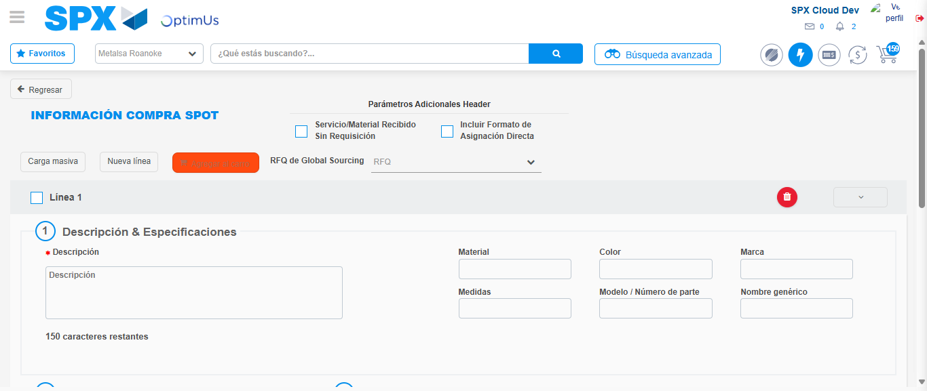Image file-name: QC_Testing-tc001_SPX_Dev5_Crear_Requisicion_Spot_Tipo_Cobro_CC-1782164635684

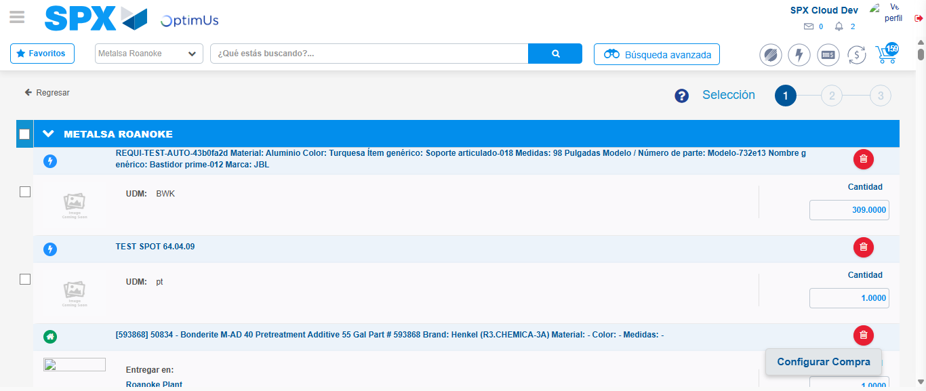Image file-name: QC_Testing-tc001_SPX_Dev5_Crear_Requisicion_Spot_Tipo_Cobro_CC-1782164647966

Image file-name: QC_Testing-tc001_SPX_Dev5_Crear_Requisicion_Spot_Tipo_Cobro_CC-1782164648155

Image file-name: QC_Testing-tc001_SPX_Dev5_Crear_Requisicion_Spot_Tipo_Cobro_CC-1782164648360

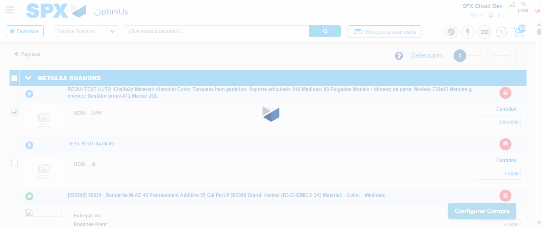Image file-name: QC_Testing-tc001_SPX_Dev5_Crear_Requisicion_Spot_Tipo_Cobro_CC-1782164650268

Step 5 - Select Type Account For Requisition : Type Account Correctly selected
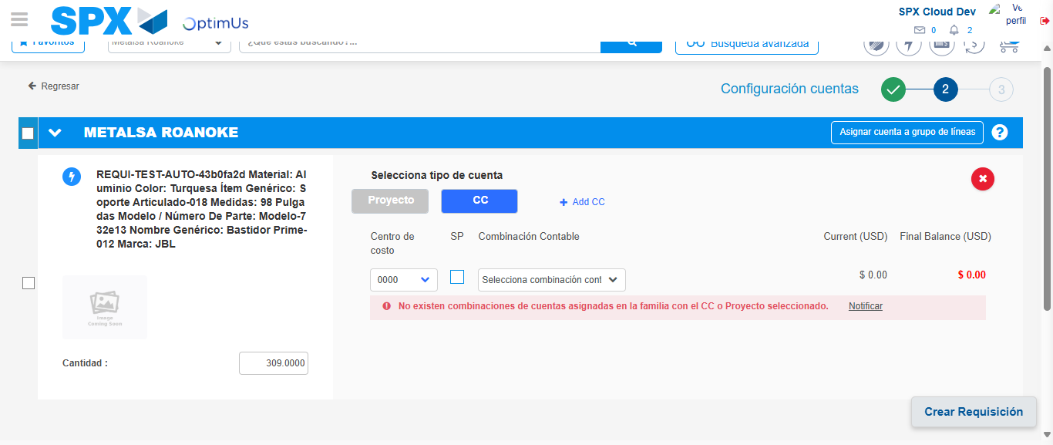Image file-name: QC_Testing-tc001_SPX_Dev5_Crear_Requisicion_Spot_Tipo_Cobro_CC-1782164665739

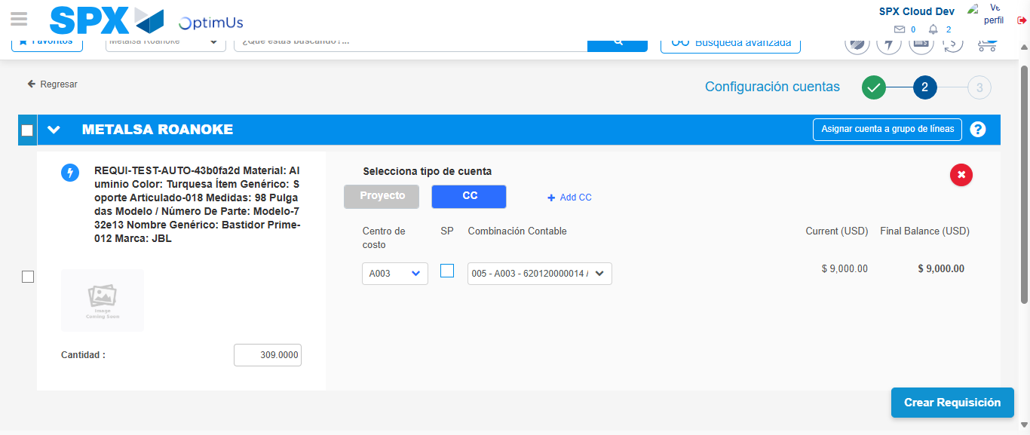Image file-name: QC_Testing-tc001_SPX_Dev5_Crear_Requisicion_Spot_Tipo_Cobro_CC-1782164671021

Image file-name: QC_Testing-tc001_SPX_Dev5_Crear_Requisicion_Spot_Tipo_Cobro_CC-1782164671195

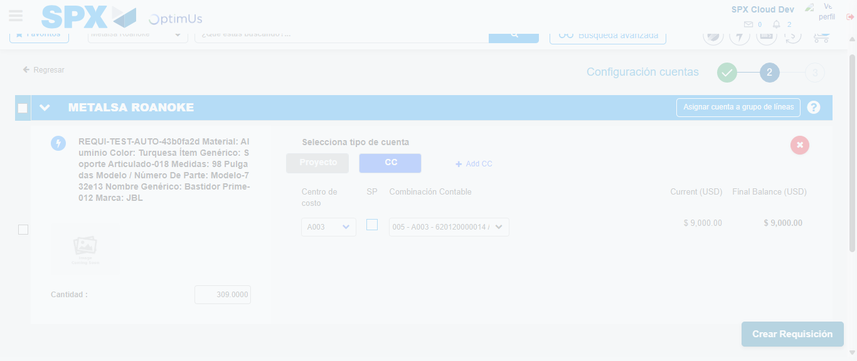Image file-name: QC_Testing-tc001_SPX_Dev5_Crear_Requisicion_Spot_Tipo_Cobro_CC-1782164671627

Step 6 - Accept to Requisition : Requisition Accepted
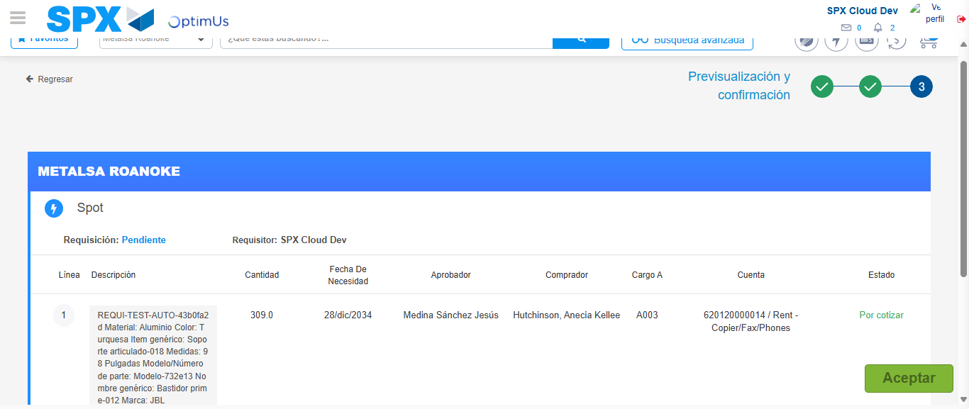Image file-name: QC_Testing-tc001_SPX_Dev5_Crear_Requisicion_Spot_Tipo_Cobro_CC-1782164672919

Image file-name: QC_Testing-tc001_SPX_Dev5_Crear_Requisicion_Spot_Tipo_Cobro_CC-1782164673126

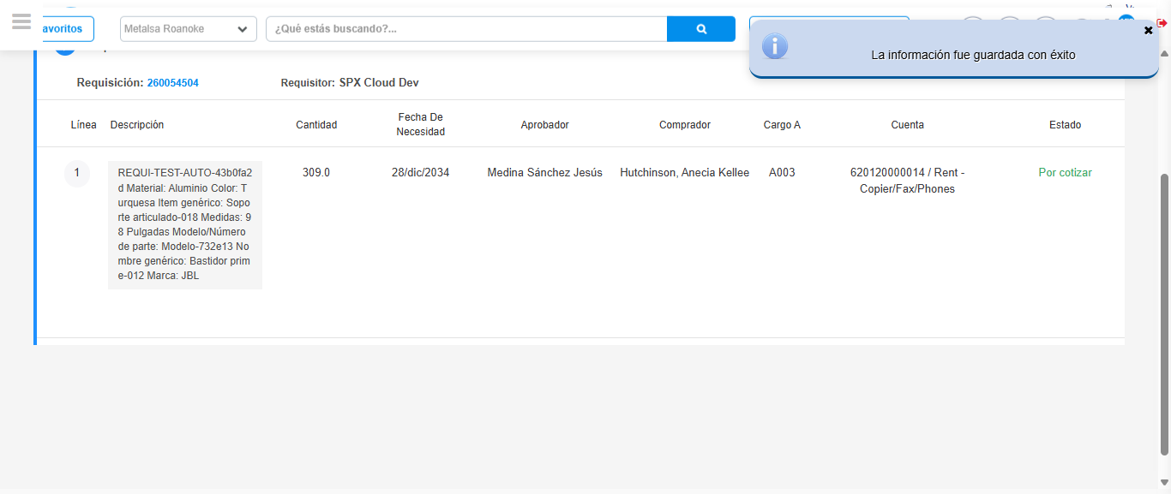Image file-name: QC_Testing-tc001_SPX_Dev5_Crear_Requisicion_Spot_Tipo_Cobro_CC-1782164676112

Step 7 - Return to Main Page SPX : Return to Main Page SPX
Image file-name: QC_Testing-tc001_SPX_Dev5_Crear_Requisicion_Spot_Tipo_Cobro_CC-1782164610884

Image file-name: QC_Testing-tc001_SPX_Dev5_Crear_Requisicion_Spot_Tipo_Cobro_CC-1782164613448

Image file-name: QC_Testing-tc001_SPX_Dev5_Crear_Requisicion_Spot_Tipo_Cobro_CC-1782164619554

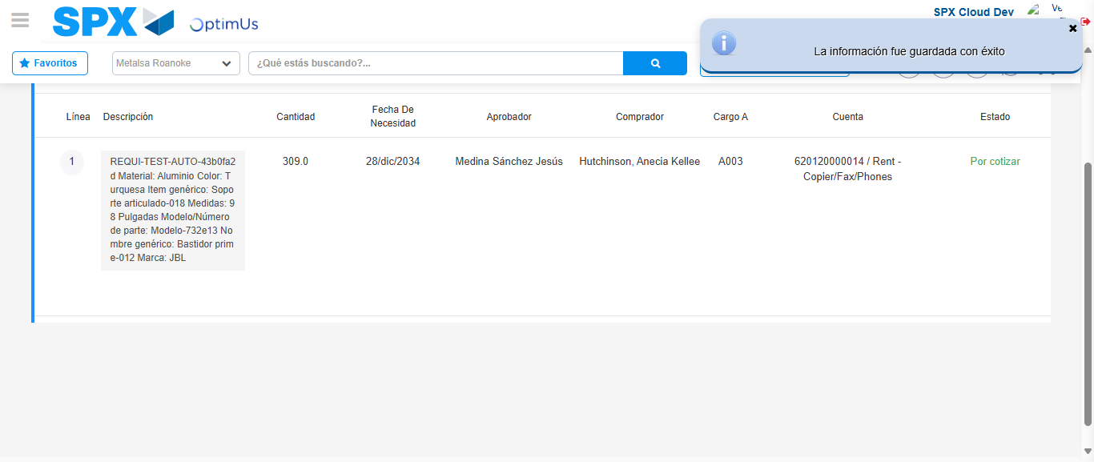Image file-name: QC_Testing-tc001_SPX_Dev5_Crear_Requisicion_Spot_Tipo_Cobro_CC-1782164678333

Image file-name: QC_Testing-tc001_SPX_Dev5_Crear_Requisicion_Spot_Tipo_Cobro_CC-1782164678455

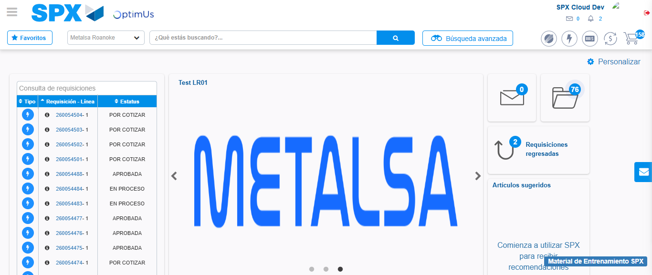Image file-name: QC_Testing-tc001_SPX_Dev5_Crear_Requisicion_Spot_Tipo_Cobro_CC-1782164699463

Step 8 - Log Out : Log Out SPX
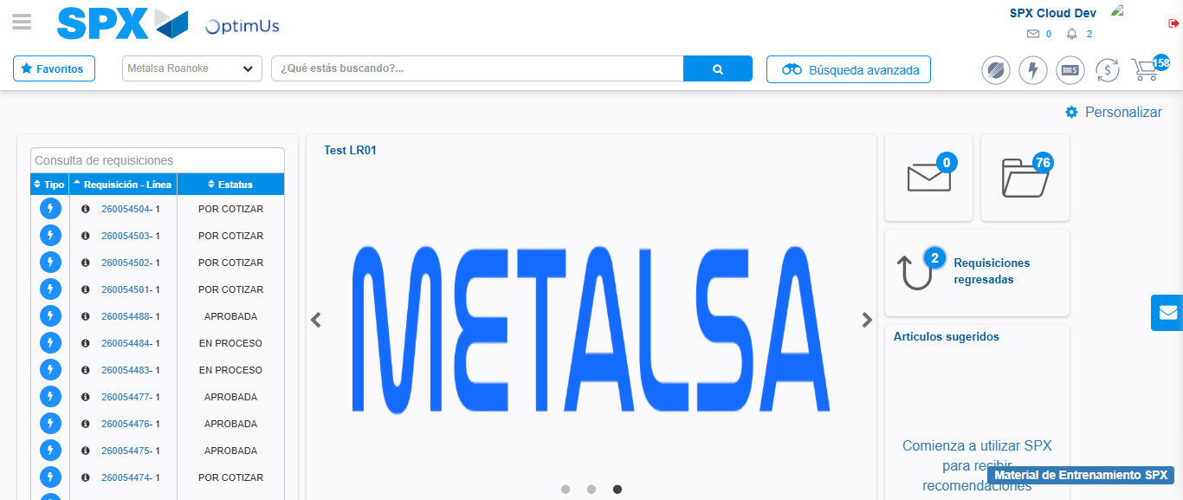Image file-name: QC_Testing-tc001_SPX_Dev5_Crear_Requisicion_Spot_Tipo_Cobro_CC-1782164699766

